Name: ________________________ Class:_______ Score:________/
Resources Allowed: Calculator, 1 page of notes (A4 two-sided), Formula sheet

Time: 55 mins Marks: 40

- [3, 2, 2 = 7 marks]
In reference to the following graph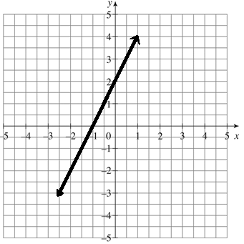
- State the;
i) gradient ii) y-intercept iii) x-intercept

- Write the equation for the line

- What is the length of the line?

- [2, 2 = 4 marks]
Determine the value of the missing side using Pythagoras

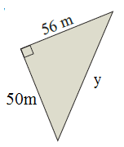 | 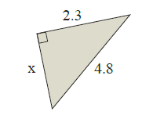

- [2, 2, 2 = 6 marks]

On the graphs y = x² below:

- Plot the graph y = x² – 3

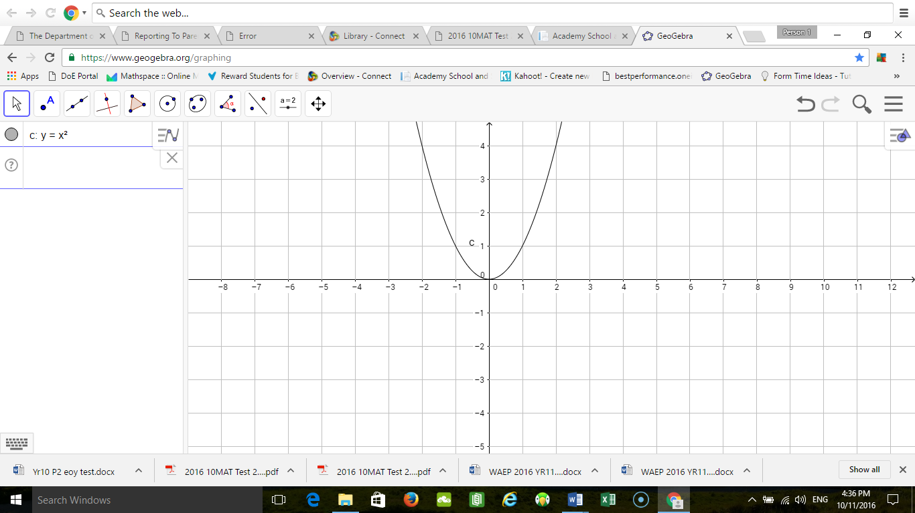

- y = (x+3)²



- y = (x + 2)² – 2



- [2, 2 = 4 marks]

- On the axes below, graph the circle ${(x-2)}^{2}+ {\left(y+1\right)}^{2}=4$

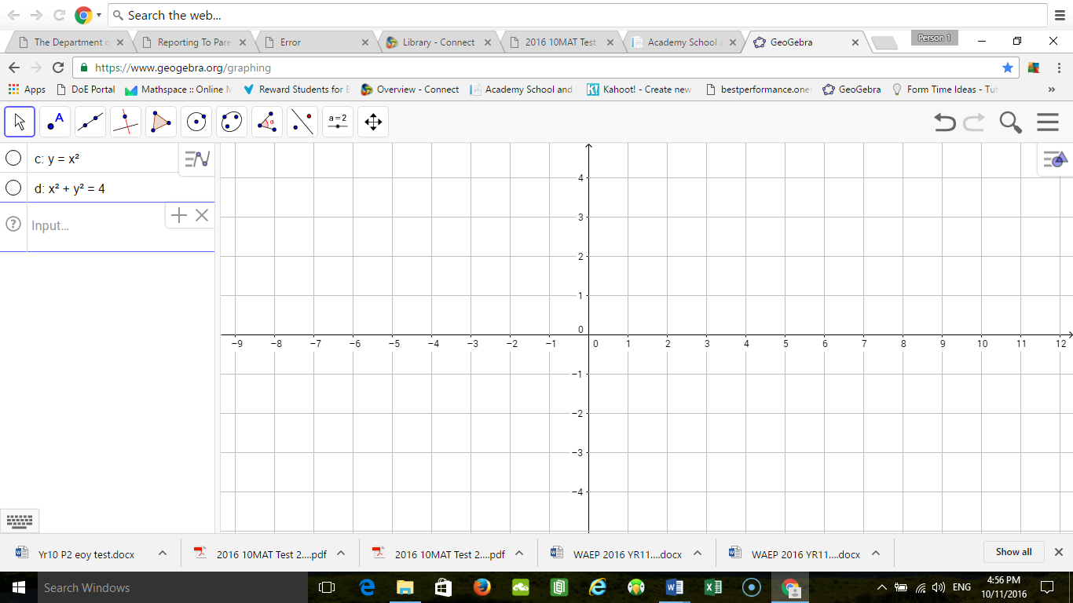

- What is the equation of a circle with a centre at (0, 3) with a radius of 2?

- (3, 3, 1 = 7 marks)
Use the following data set to answer these questions:

6 | 28 | 26 | 32 | 30 | 32 | 28 | 35 | 33 | 33 | 39

- Find the median

- Find the mean

- Find the mode

- (3 Marks)
What is the effect on the mean, median and mode of removing the outlier from the above data set?

- (5, 4 = 9)
5 | 15 | 20 | 21 | 25 | 27 | 27 | 28 | 30 | 35

- Use the above data set to find the five number summary to construct a box and whisker plot.
Min | Q₁ | Median | Q₃ | Max

- Use your values from a) to construct a box and whisker plot in the space provided below:



End of Test

